Session 4

## A Door in the Mountainside

Before the players is a massive open vault door revealing a seemingly endless corridor down into the mountain.

## Inside the Vault

### 1: Entrance Room

As the party reaches the bottom of the stairs, glowing blue fungus begins to light their way. Most of the entrance room is covered in these blue mushrooms, mostly on the walls and ceiling. There are a couple of carts in the corner of the room with a green bar on the front of them.

* If the fungus is touched, anyone in the room is attacked by a level 3 INT attack. If it hits the PC is stunned.

The fungus has 6 health and can be hurt by fire or INT attacks.

* This room has 3 doors.
  + There is a mechanical lock on the heavy metal door on the left. Picking it is a LV 4 INT task. Leads to R2.
  + The door ahead will not open until power is restored. And opens to the carts. It also has a green bar across the top of the door. Leads to R4.
  + The door on the right is also not accessible without power. Hacking the lock is LV 4 INT task. Leads to R3.

### 2: Generator Room

The room is dark on first entry with a large machine with glowing green light creeping out through windows in the side of it. There is also a control panel on the opposite wall.

* There is a Geiger counter in one corner of the room. It is initially silent. (Oddity)
* Repairing the reactor is a LV 5 INT task and reactivating it is a LV 3 INT task. This activates power in the facility and turns on all lights. The green glow gets brighter.
* 6 Shins can be found in the room in components.
* There is one door to R1

### 3: Cryo Room

This room contains in the middle of it a huge tank of blue fluid. There are many pipes going to and from the tank along the ceiling and walls. Many have ice crystalizing on them. There is a bank of valves and controls along one wall.

* The room contains 7 shins in components. Also a Frigid Wall Projector.
* The cryochamber can be shut off by a LV 3 INT check at the valves. Failure sprays the PC with a freezing mist inflicting 4 damage.
* There are 2 unlocked doors
  + The north door goes to R4
  + The west door goes to R1

### 4: Main Hallway

The hall is overgrown with vines and plants coming out of cracks in the wall. A few vines hang down in front of the door to R7.

The vines will try to pull in and strangle anyone under them. Two blossoms on the East wall spit venom.

* Encounter initiates when plants attacked or vines touched
* There are 5 doors in this hall
  + The door to R7 requires a cart
  + The door to R3 is a LV4 INT check if not opened from the inside
  + The door to R1 requires the cart
  + The doors to R5 and R6 are unlocked.

**Encounter**

**Vines LV3**

Health: 12

Damage Inflicted: 4

Movement: None

* PCs under the vines are attacked. If it hits, they are stunned and pulled to the ceiling. They get attacked each turn until one is resisted.

**Spitters (x2) LV2**

Health: 6

Damage Inflicted: 3

Movement: Short

* Attacks are ranged and remove armor on hit

*Loot: Explosive Poison Sack*

### 5: Storeroom

This room is heavily overgrown with fruit bearing plants.

*Loot: 10 glow fruit*

### 6: Research Room

This room is full of microscopes and lab equipment

*Loot: 8 Shins, Coffee maker*

### 7: Cold Storage

This is a vast room filled with racks with circular drawers

* If the Cryochamber has not been deactivated, the drawers are locked. Otherwise they can be opened and have steam pouring out of them.
* The drawers contain unidentifiable seeds
* Once a drawer is opened, red lights will come on throughout the facility. A siren and an untranslatable voice will come on. The door to the vault will begin to close. The door will lock when it closes.

After the warning lights come on, the PCs will have to flee. After closing the door at the entrance, the generator will explode destroying everything in the vault.

# Small Town (Get name from Map)

## Blink and Blank

Brothers who run a small general store. Blink has 4 eyes, blank has none.

## Markov

An old farmer. He is a nano who likes to lay low.

# An Expedition

The Amber papacy wants to launch an expedition into the mysterious ironwood. The guars however are refusing to provide protection for the expedition, but they will hire the party.

They will accompany 3 amber priests: Ella (kind, bright green eyes), Benk (tall, curious) and Donin (old, cautious)

## Electrical Sprites (optional)

Balls of energy that flit between the trees. One touch can stop a man’s heart. It is unclear if they are hostile, or curious and unaware of their own danger

If the PC’s get their attention they will begin coming toward them.

### Electrical Sprites (LV2)

Attack for 6

If hit with conductive weapons, deal 6 damage.

## Night Encounters

### Band of Culova (14+)

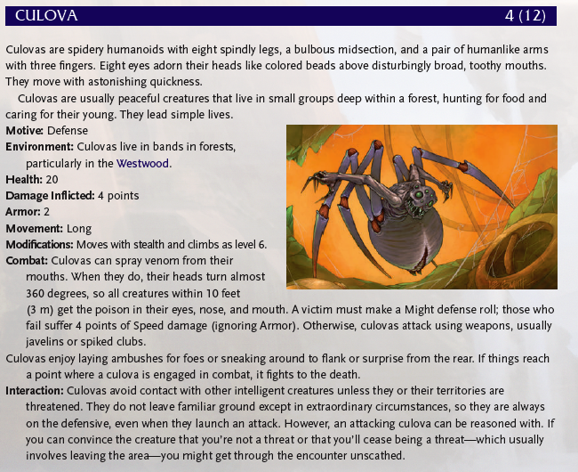

### Nibovian Companion (on a 17+)

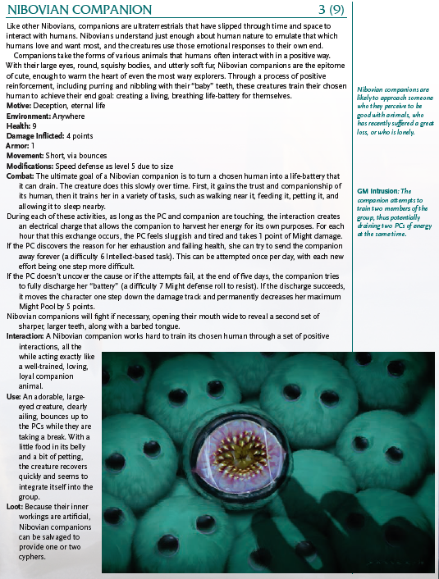

## Cultists

There are cultists in these woods wearing black and green robes. They are a radical sect of Hestans.

If followed they will eventually go back to a stone step pyramid.

## Dream Sallow

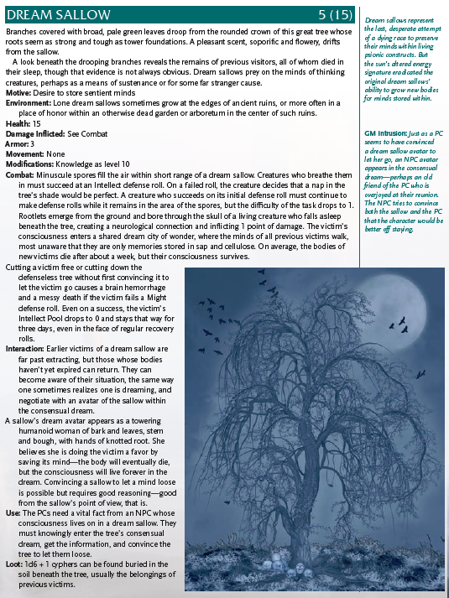

# Ironwood Ideas

## Electrical Sprites

Balls of energy that flit between the trees. One touch can stop a man’s heart. It is unclear if they are hostile, or curious and unaware of their own danger.

# Back in Town

Many of the windows of the Order of Truth’s church are broken. Rask is furious.

In the market, a priest in a black and green robe proclaims how the Amber order mocks Hestor and must be resisted.

A man in the market has a pet stall.

Sonto refuses to protect the Order of Truth. If asked, it’s politics. They are required by Oslo to allow them, but siding with them would be unpopular among the people and the mayor will not permit it.

One of the numinera books for sale details a kind of power source the players can harness for the fortress.